ECTN Racconti Mediteranei
Autumn School 2011

from Natasa Simic and Carlo Guerra

THERE ARE MANY WAYS…

As you probably know, Racconti Mediterranei is a summer school organized by the European Constructivist Training Network (ECTN). Its aim is to promote projects and exchange of ideas between teachers, students and other supporters of constructivism. All participants are highly involved in diverse activities because we all believe that such diversity enriches our competencies, fosters creativity and broadens horizons.

This year RM3 was transformed from a summer school into an autumn school since it was organized in Brno, the capital city of Moravia (Czech Republic) from 23rd to 30th October. The theme that brought together 50 individuals from Italy, Serbia, Czech Republic and UK was “Skills and Strategies for the Inquiring Person”.

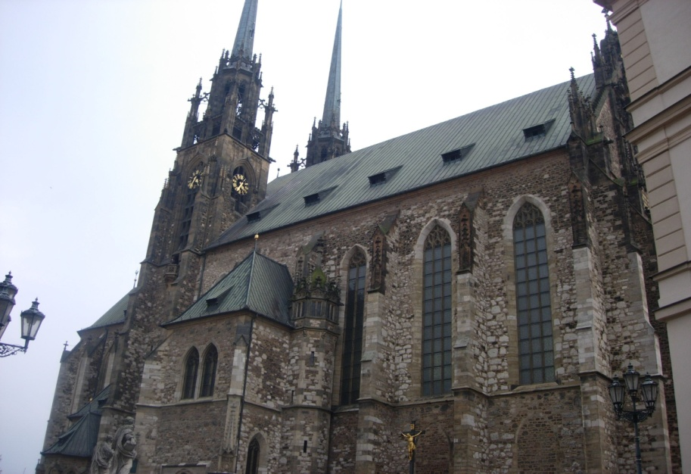

There are many ways to describe Racconti Mediterranei. It can be seen as one-week training, but at the same time, an opportunity to explore constructivism (and constructivists) from different perspectives, to have fun and make friends. In the following text we will try to present all the different aspects of RM3 that made it a wonderful experience.

1. Workshops led by our teachers

RM3 was a wonderful opportunity for both experienced and incipient constructivist scientists to experiment and elaborate different roles such as role of a therapist, client, listener, story teller etc. It also enabled us to broaden our knowledge of the theory and techniques as well as to meet other fellow constructivist and understand their experience and their stories. Our teachers and mentors Mary Frances, Massimo Giliberto and Dušan Stojnov made RM3 valuable by carefully selecting topics and skillfully conducting workshops:

Massimo Giliberto presented his approach to Narratives as Paths to Inquiry, where he pointed to the relationship between narrative and paradigmatic thought, person as a story-teller and as a scientist. Within his approach he introduced us to the Narrative Theme Method, a useful and inspiring tool for exploration of psychological process that embraces life role, narrative theme of entire life, influences of important people’s narratives, questions and choices they lead to etc. Many group and pair activities were undertaken.

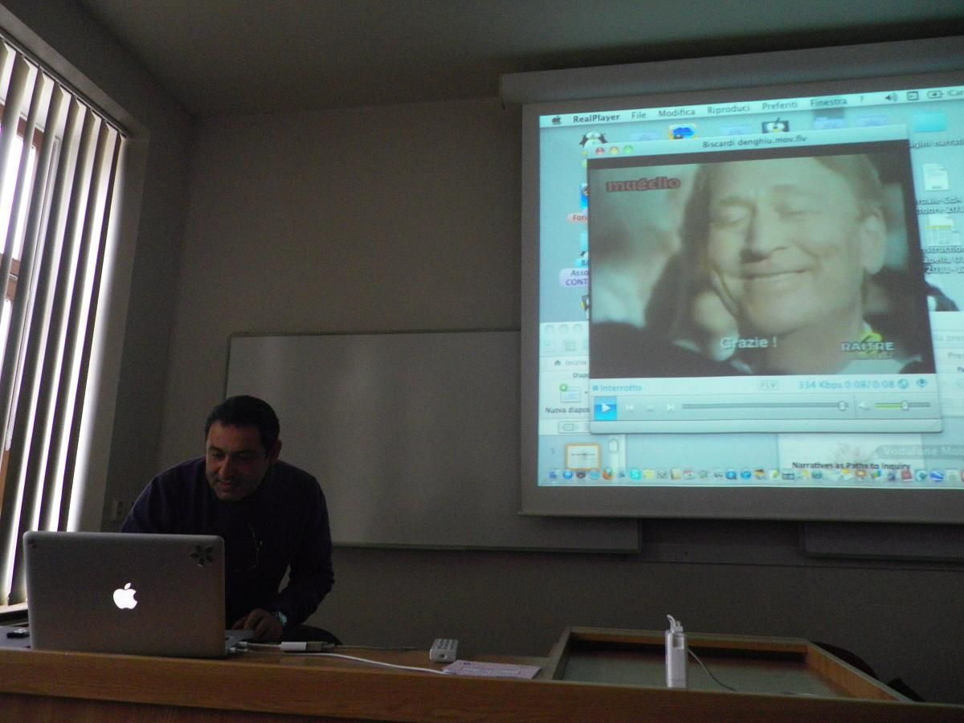

In her presentation Relationships as work in progress, Mary Frances pointed to Wittgenstein’s notion of communication and the relationally responsive nature of our interactions referred to by Shotter. The main activity of the workshop was Mapping and describing relationships-in-progress. In the second part we discussed in groups different dimensions of relationships with a special emphasis on cultural differences.

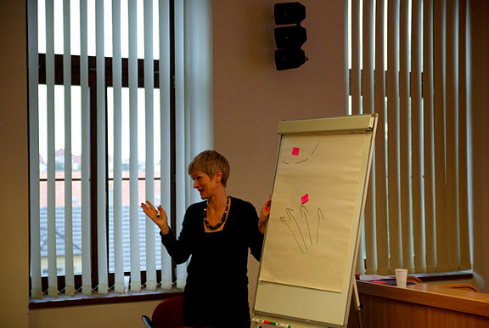

In the second workshop, she introduced her new technique Pixpeg which enabled us to discover the power of using photos as stimuli for eliciting constructs regarding relationships.

Dušan Stojnov organized a workshop named Coaching Persons-as-scientists: Constructivist methodologies for an inquiring person. A new perspective of coaching psychology immersed in constructivist meta-theory was presented and an appreciative understanding of inquiring persons was underlined. The framework for the workshop was optimizing personal/organizational functioning by elaborating the differences between good and bad science through analyses of logical fallacies.

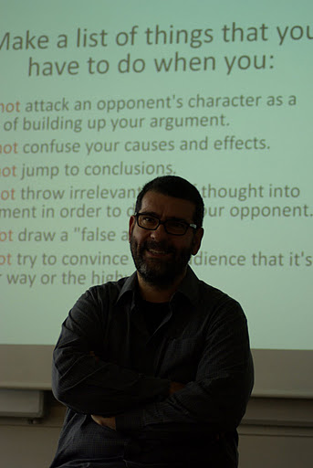

One of our hosts, Mirek Filip presented his experience of working with schizophrenic patients and his understanding of their construing. Schizophrenia is considered to be a highly dynamic mixture of extreme loosening-tightening and fragmentation-integration. Through group work, we created and enacted dialogues about different levels of “schizophrenic” construing: “normal”, extreme and paranoid/thought disorder.

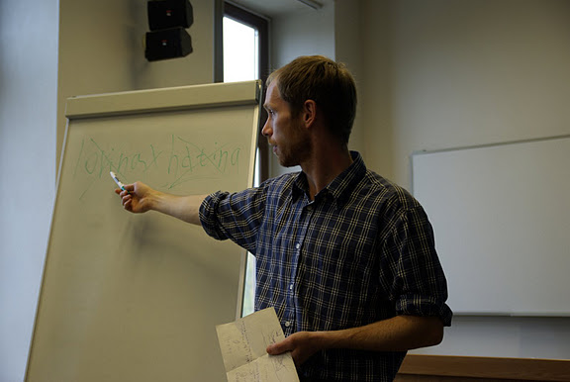

2. Activities dealing with constructivism from the point of view that is not strictly psychological

...Workshop “Theater of the oppressed”, organized by the Czech students. Two topics that were elaborated through movements and play were Inequality in labor market and prejudices toward adolescents.

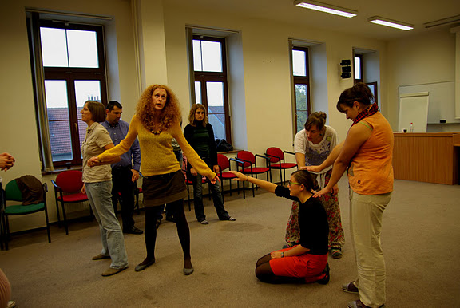

Friday evening was reserved for Dush’s music café, enriched with enjoying delicious wine and beer. We will remain silent about later hours of the party…☺

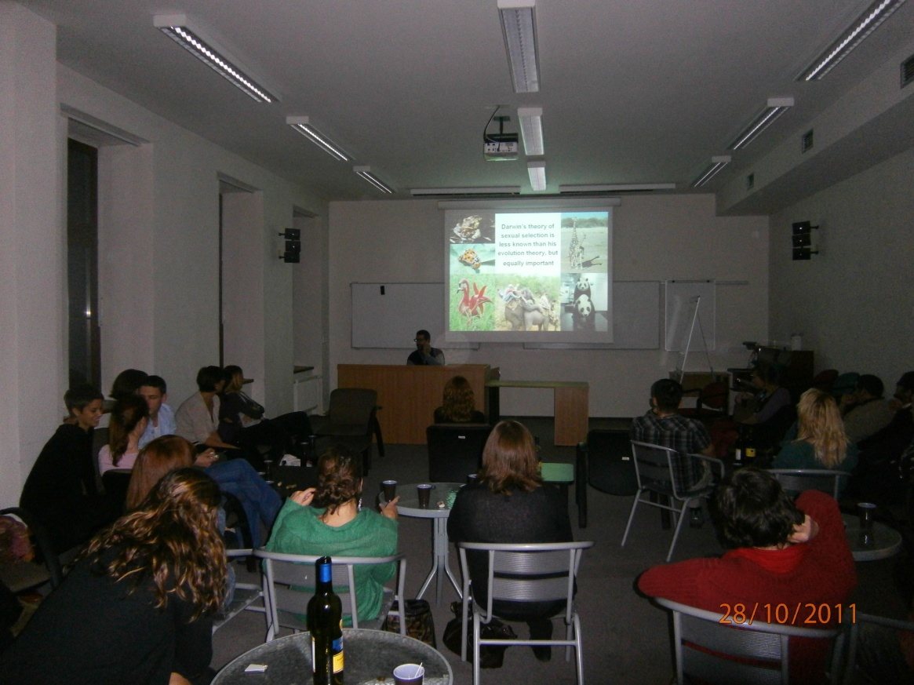

3. Free time activities

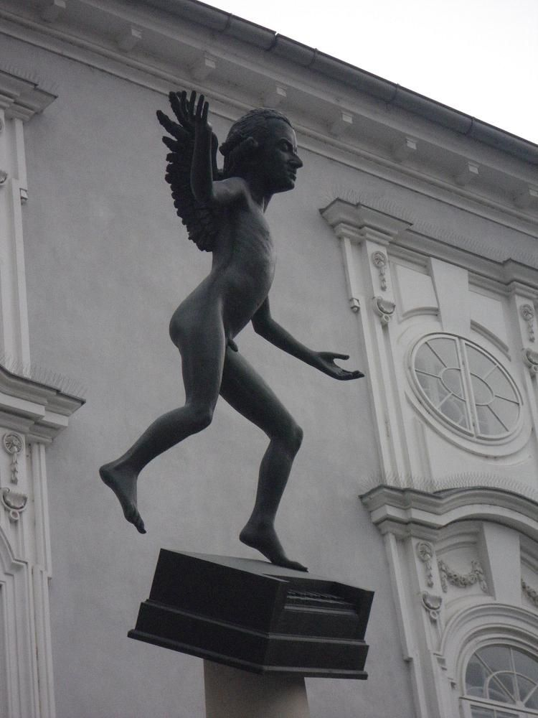

...We enjoyed making our way through Brno by following a map made of photos of the most important sights of Brno... That was the first opportunity to taste world famous beer in an authentic ambience of a Czech pub.

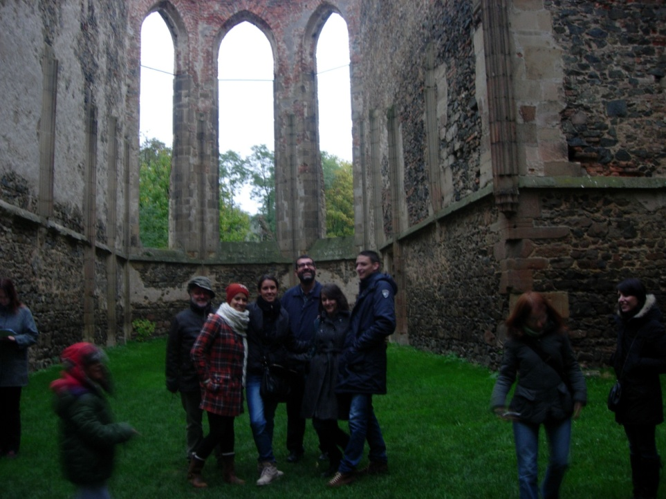

...Two impressive monasteries, which enabled us to experience the spirit of the past. After a historical journey we indulged in traditional honey cakes and delicious wine.

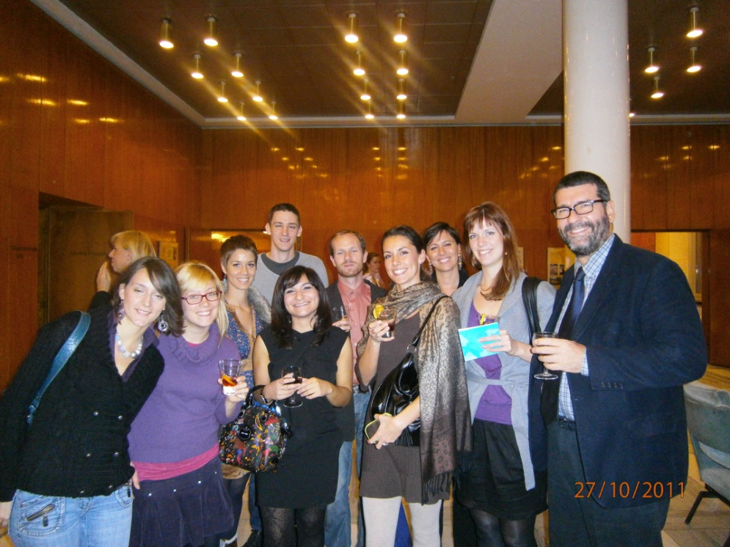

...Several participants of RM3 went to Smetana’s opera “The Bartered Bride”, the most performed opera in the Czech Republic.

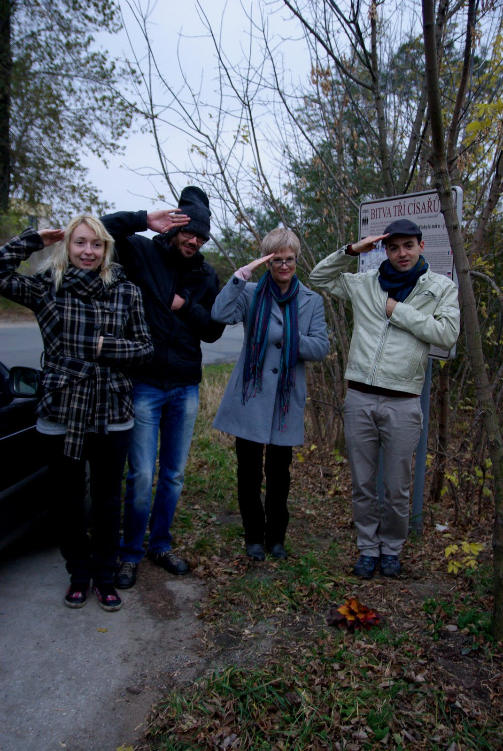

... Some participants visited the field where the famous battle of Austerlitz took place.

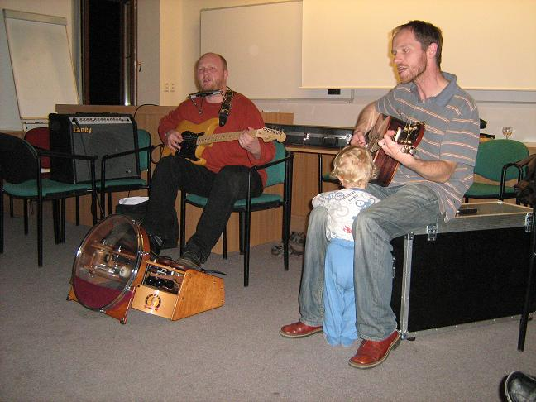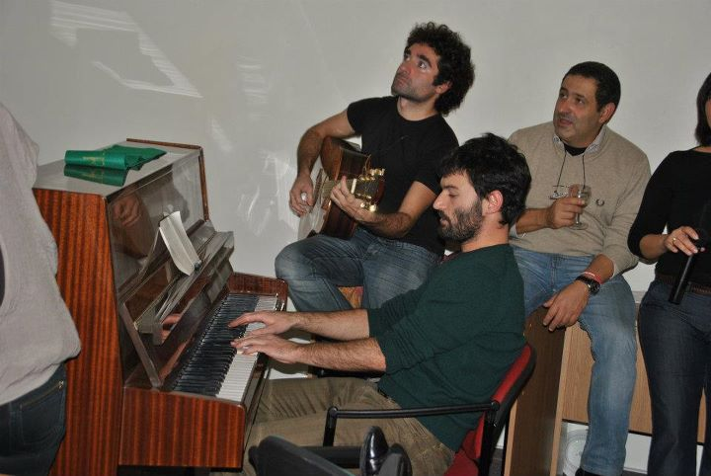

The last evening... Our lovely hosts organized wine tasting and dinner and we enjoyed a great concert of Czech music played by one of constructivists, Tomasz Stefan. We finished off our last evening with dancing, playing the guitar and the piano and singing.

3. The Human Relationships

What gives RM that pleasant and at the same time “sparkling” atmosphere is the “social factor”. At the beginning one can see early distrust, shyness and groups made up of familiar persons at lunch, but after a few days, “fate” brings us togheter. We don’t avoid each other, but we look for the other. We don’t have to say much, now we understand each other without words. There is always a person near you with whom you can share a thought, a joke, a feeling… And raising the glass during the farewell party makes you feel happy because you know that you have met wonderful people and experienced a magical atmosphere, but, at the same time, it makes you feel a bit melancholic because you know that everybody will miss you and you will miss them...



